Mayekar Technologies Pvt. Ltd.
ISO/IEC 27001:2022
INFORMATION SECURITY RISK TREATMENT PLAN (RTP)
Document Number
MTPL-ISMS-015
Version
1.0
Prepared By
Omkar Abhay Mayekar
ISMS Project Developer
Reviewed By
Alankar Abhay Mayekar
Information Security Manager
Approved By
Aakanksha Abhay Mayekar
Chief Executive Officer (CEO)
Classification
Internal Use Only
Effective Date
01 August 2026

Document Control
Document Information | Details
Document Title | Information Security Risk Treatment Plan
Document ID | ISMS-RTP-015
Version | 1.0
Document Type | Controlled Document
Document Category | ISMS Mandatory Document
Classification | Internal Use Only
Prepared By | Omkar Abhay Mayekar - Information Security Management System (ISMS) Team
Reviewed By | Alankar Abhay Mayekar - Information Security Manager
Approved By | Aakanksha Abhay Mayekar - Chief Executive Officer (CEO)
Effective Date | 01-Aug-2026
Next Review Date | 31-Jul-2027
Document Owner | Information Security Manager
Document Location | ISMS Document Repository
Retention Period | 7 Years
Distribution | Management, Information Security Team, Department Heads, Internal Auditors
Related Documents | Information Security Risk Assessment Methodology, Information Security Risk Register, Statement of Applicability (SoA), Information Security Policy

Document Version History
Version | Date | Description of Changes | Prepared By
1.0 | 01-Aug-2026 | Initial Release | ISMS Team

Document Approval
Name / Designation | Role | Signature | Date
Alankar Abhay Mayekar - Information Security Manager | Reviewed By | __________ | __________
Aakanksha Abhay Mayekar - Chief Executive Officer (CEO) | Approved By | __________ | __________

Document Distribution
This document shall be distributed to the following stakeholders:
- Executive Management
- Information Security Manager
- ISMS Team
- Department Heads
- Internal Auditors
- Process Owners
- Authorized Personnel involved in Risk Treatment Activities

Document Review Statement
This Information Security Risk Treatment Plan shall be reviewed at least annually or whenever significant changes occur to the organization's business processes, information assets, technology infrastructure, legal or regulatory requirements, identified risks, or the Information Security Management System (ISMS). Any amendments shall be reviewed, approved, version-controlled, and communicated to relevant stakeholders in accordance with the organization's Document Control Procedure.

1. Purpose
The purpose of this Information Security Risk Treatment Plan (RTP) is to establish a structured and consistent approach for selecting, implementing, monitoring, and reviewing appropriate treatment actions for identified information security risks within Mayekar Technologies Private Limited. The plan ensures that all identified risks are treated in accordance with the organization's risk acceptance criteria, business objectives, legal and regulatory requirements, and the requirements of ISO/IEC 27001:2022.
This document provides the framework for reducing information security risks to acceptable levels through the implementation of appropriate security controls, assignment of responsibilities, allocation of resources, establishment of target completion dates, and continuous monitoring of treatment effectiveness. It also supports management in making informed risk-based decisions while protecting the confidentiality, integrity, and availability (CIA) of organizational information assets.
The Risk Treatment Plan serves as a key component of the Information Security Management System (ISMS) by ensuring that risk treatment activities are systematically planned, executed, documented, and periodically reviewed, thereby contributing to continual improvement, regulatory compliance, operational resilience, and the overall effectiveness of the organization's information security governance.

2. Scope
This Information Security Risk Treatment Plan applies to all information assets, business processes, information systems, applications, databases, network infrastructure, cloud services, physical facilities, and supporting technologies that fall within the defined scope of the Information Security Management System (ISMS) of Mayekar Technologies Private Limited.
The plan is applicable to all employees, management personnel, contractors, consultants, third-party service providers, and other authorized stakeholders who are responsible for implementing, managing, reviewing, or supporting information security risk treatment activities.
This document covers the treatment of risks identified through the Information Security Risk Assessment process, including the selection of appropriate treatment options, implementation of applicable security controls, assignment of risk ownership, monitoring of treatment effectiveness, and periodic review to ensure that residual risks remain within the organization's approved risk acceptance criteria.
The Risk Treatment Plan supports the implementation of applicable ISO/IEC 27001:2022 Annex A controls and aligns with the organization's business objectives, legal and regulatory obligations, contractual commitments, and continual improvement requirements of the Information Security Management System (ISMS).

3. References
The following standards, policies, procedures, and documented information have been referenced during the development and implementation of this Information Security Risk Treatment Plan:
Reference | Description
ISO/IEC 27001:2022 | Information Security Management Systems (ISMS) – Requirements
ISO/IEC 27002:2022 | Information Security Controls – Implementation Guidance
Information Security Policy | Defines the organization's information security principles and governance framework.
Information Security Risk Assessment Methodology | Establishes the process for identifying, analyzing, evaluating, and prioritizing information security risks.
Information Security Risk Register | Contains the identified information security risks, risk ratings, ownership, and treatment requirements.
Statement of Applicability (SoA) | Documents the applicability and implementation status of ISO/IEC 27001:2022 Annex A controls.
Asset Register | Provides an inventory of information assets and their assigned ownership.
Document Control Procedure | Defines the process for creating, reviewing, approving, distributing, and maintaining controlled documents.
Applicable Legal, Regulatory and Contractual Requirements | Includes all relevant statutory, regulatory, contractual, and business obligations related to information security.

4. Risk Treatment Methodology
4.1 Overview
The Information Security Risk Treatment Methodology defines the systematic approach adopted by Mayekar Technologies Private Limited to treat identified information security risks in a consistent, effective, and risk-based manner. The methodology ensures that all identified risks are evaluated against the organization's risk acceptance criteria and appropriate treatment actions are selected to reduce risks to acceptable levels while supporting business objectives and regulatory compliance.
Risk treatment activities are performed based on the results of the Information Security Risk Assessment process and include the selection, implementation, monitoring, and continual review of appropriate security controls in accordance with ISO/IEC 27001:2022 and the organization's Information Security Management System (ISMS).
4.2 Risk Treatment Process
The organization follows the following structured process for managing information security risk treatment:
- Review identified risks from the Information Security Risk Register.
- Evaluate the risk rating and determine whether treatment is required.
- Select the appropriate risk treatment option.
- Identify and assign applicable ISO/IEC 27001:2022 Annex A controls.
- Develop and implement the Risk Treatment Plan.
- Assign ownership and target completion dates.
- Monitor implementation progress and verify control effectiveness.
- Assess residual risk after implementation.
- Obtain management approval for residual risk.
- Perform periodic review and continual improvement.

4.3 Risk Treatment Flow
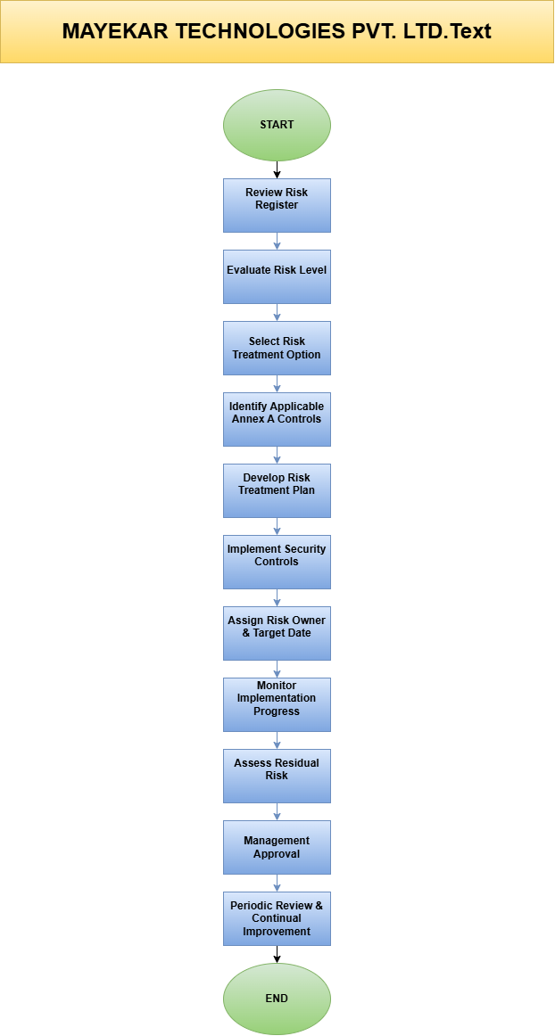
4.4 Risk Treatment Principles
The organization shall ensure that:
- Risk treatment decisions are based on the approved Risk Assessment results.
- Appropriate Annex A controls are selected and implemented.
- Responsibilities and ownership are clearly assigned.
- Treatment actions are completed within the approved timelines.
- Residual risks remain within the organization's defined risk acceptance criteria.
- Risk treatment activities are documented, monitored, and periodically reviewed.
- Continual improvement is achieved through regular monitoring, audits, and management reviews.

5. Risk Treatment Options
5.1 Overview
Following the completion of the Information Security Risk Assessment, each identified risk shall be evaluated to determine the most appropriate treatment option. The selected treatment option shall be based on the organization's risk acceptance criteria, business objectives, legal and regulatory obligations, operational requirements, and the cost-effectiveness of implementing security controls. The objective of risk treatment is to reduce information security risks to an acceptable level while maintaining the confidentiality, integrity, and availability of organizational information assets.

5.2 Risk Treatment Options
The organization adopts one or more of the following risk treatment options for managing identified information security risks:

5.2.1 Risk Mitigation
Risk Mitigation involves implementing appropriate administrative, technical, and physical security controls to reduce either the likelihood or the impact of an identified risk. This is the most commonly adopted treatment option within the organization and includes the implementation of ISO/IEC 27001:2022 Annex A controls, security technologies, policies, procedures, user awareness programs, and continuous monitoring activities.

5.2.2 Risk Acceptance
Risk Acceptance is applied when the residual risk remains within the organization's approved risk acceptance criteria and no additional treatment is considered necessary. Accepted risks shall be formally documented, justified, approved by management, and periodically reviewed to ensure they continue to remain within acceptable limits.

5.2.3 Risk Transfer
Risk Transfer involves shifting all or part of the financial or operational impact of a risk to an external party through contractual agreements, outsourcing arrangements, cyber insurance, managed security services, or other legally binding mechanisms. Although the responsibility for managing information security remains with the organization, the impact of specific risks may be partially transferred.

5.2.4 Risk Avoidance
Risk Avoidance is achieved by eliminating the activity, business process, technology, or service that gives rise to an unacceptable information security risk. This option is generally considered when the identified risk exceeds the organization's risk tolerance and cannot be effectively reduced through reasonable security controls.

5.3 Risk Treatment Selection Criteria
The selection of an appropriate risk treatment option shall consider the following factors:
- Risk rating and priority.
- Business objectives and operational requirements.
- Legal, regulatory, and contractual obligations.
- Cost and feasibility of implementing security controls.
- Effectiveness of proposed treatment measures.
- Availability of technical and organizational resources.
- Organizational risk appetite and acceptance criteria.
- Residual risk after treatment implementation.

5.4 Risk Treatment Decision Matrix
Treatment Option | Objective | Typical Example
Mitigate | Reduce the likelihood and/or impact of the risk by implementing security controls. | Deploy MFA, EDR, encryption, backup, security awareness training.
Accept | Accept the residual risk because it falls within the approved risk tolerance. | Low-impact operational risk accepted by management.
Transfer | Transfer the financial or operational impact through contractual or commercial arrangements. | Cyber insurance, cloud service agreements, managed security services.
Avoid | Eliminate the activity or process causing the unacceptable risk. | Decommissioning an insecure legacy application or discontinuing a high-risk service.

5.5 Implementation Statement
The selected risk treatment option for each identified information security risk shall be documented within the Information Security Risk Treatment Plan and monitored until the planned treatment activities have been successfully completed. The effectiveness of implemented controls shall be verified through periodic reviews, internal audits, management reviews, and continual improvement activities to ensure that residual risks remain within the organization's approved risk acceptance criteria.

6. Risk Acceptance Criteria
6.1 Overview
Risk Acceptance Criteria define the conditions under which identified information security risks may be accepted by Mayekar Technologies Private Limited after evaluation and, where applicable, implementation of appropriate risk treatment measures. These criteria provide a consistent framework for determining whether residual risks are within the organization's approved risk appetite and can be accepted by management without requiring additional security controls.
Risk acceptance decisions shall be based on business objectives, legal and regulatory obligations, contractual commitments, operational requirements, and the potential impact on the confidentiality, integrity, and availability (CIA) of information assets. All accepted risks shall be formally documented, justified, approved by the appropriate authority, and periodically reviewed.

6.2 Risk Acceptance Criteria
The organization shall consider a risk acceptable only when one or more of the following conditions are satisfied:
- The residual risk falls within the organization's approved risk appetite.
- Appropriate risk treatment measures have been implemented and verified.
- The cost of additional controls exceeds the potential business benefit.
- Legal, regulatory, and contractual obligations continue to be satisfied.
- The risk does not significantly affect business continuity or critical operations.
- Management has formally approved the acceptance of the residual risk.
- The accepted risk is recorded in the Risk Register and is subject to periodic review.

6.3 Risk Acceptance Matrix
Risk Level | Acceptance Decision | Required Action
Low | Acceptable | Monitor through routine reviews.
Medium | Conditionally Acceptable | Implement appropriate treatment actions and monitor effectiveness.
High | Not Acceptable | Risk treatment shall be implemented before acceptance can be considered.
Critical | Unacceptable | Immediate treatment and executive management approval are mandatory.

6.4 Risk Acceptance Authority
Risk Level | Approval Authority
Low | Information Security Manager
Medium | Department Head & Information Security Manager
High | Chief Executive Officer (CEO)
Critical | Chief Executive Officer (CEO) with Executive Management Approval

6.5 Risk Acceptance Requirements
Before any identified risk is accepted, the following requirements shall be fulfilled:
- Risk assessment shall be completed and documented.
- Applicable risk treatment options shall be evaluated.
- Residual risk shall be determined and recorded.
- Risk owner shall provide documented justification.
- Required management approval shall be obtained.
- Accepted risks shall be monitored and reviewed periodically.
- Any significant change affecting the accepted risk shall trigger a reassessment.

6.6 Implementation Statement
All accepted information security risks shall remain subject to continual monitoring, periodic review, and reassessment to ensure that they continue to remain within the organization's approved risk acceptance criteria. Where changes in business operations, technology, legal obligations, threat landscape, or risk exposure occur, previously accepted risks shall be re-evaluated and additional treatment measures implemented where necessary.

7. Applicable Annex A Controls
7.1 Overview
The organization shall select and implement appropriate information security controls based on the results of the Information Security Risk Assessment and Risk Treatment process. Control selection shall be performed in accordance with ISO/IEC 27001:2022 Annex A and shall consider the nature of identified risks, business objectives, legal and regulatory obligations, contractual requirements, and operational needs. The selected controls are intended to reduce identified risks to acceptable levels while supporting the confidentiality, integrity, and availability of organizational information assets.
The applicability, implementation status, and justification for each selected control shall be documented within the organization's Statement of Applicability (SoA). The controls listed in this document represent the primary security controls applicable to the Risk Treatment Plan.

7.2 Applicable Annex A Controls
Annex A Control ID | Control Name | Purpose | Implementation Status
A.5.1 | Policies for Information Security | Establish information security policies. | Implemented
A.5.9 | Inventory of Information and Other Associated Assets | Maintain an accurate inventory of assets. | Implemented
A.5.10 | Acceptable Use of Information and Other Associated Assets | Ensure proper use of organizational assets. | Implemented
A.5.15 | Access Control | Restrict unauthorized access to information. | Implemented
A.5.23 | Information Security for Use of Cloud Services | Secure cloud-based services and data. | Implemented
A.5.30 | ICT Readiness for Business Continuity | Support business continuity during disruptions. | Implemented
A.6.3 | Information Security Awareness, Education and Training | Improve employee security awareness. | Implemented
A.6.7 | Remote Working | Protect information during remote work. | Implemented
A.8.1 | User Endpoint Devices | Secure laptops, desktops, and mobile devices. | Implemented
A.8.7 | Protection Against Malware | Prevent, detect, and respond to malware threats. | Implemented
A.8.8 | Management of Technical Vulnerabilities | Identify and remediate technical vulnerabilities. | Implemented
A.8.9 | Configuration Management | Maintain secure system configurations. | Implemented
A.8.13 | Information Backup | Ensure reliable backup and recovery. | Implemented
A.8.15 | Logging | Record security-related activities for monitoring. | Implemented
A.8.16 | Monitoring Activities | Continuously monitor security events and incidents. | Implemented
A.8.24 | Use of Cryptography | Protect sensitive information using encryption. | Implemented
A.8.28 | Secure Coding | Reduce software security vulnerabilities. | Implemented

7.3 Control Selection Criteria
The organization selects Annex A controls based on the following criteria:
- Results of the Information Security Risk Assessment.
- Risk Treatment Plan requirements.
- Legal and regulatory obligations.
- Contractual and customer requirements.
- Business objectives and operational needs.
- Effectiveness and feasibility of the proposed control.
- Organizational risk appetite and risk acceptance criteria.
- Availability of financial, technical, and human resources.

7.4 Implementation Statement
All applicable Annex A controls shall be implemented, monitored, maintained, and periodically reviewed to ensure their continued effectiveness. Control implementation shall be verified through internal audits, management reviews, security monitoring activities, and continual improvement initiatives. Any control identified as not applicable shall be documented with appropriate justification in the Statement of Applicability (SoA), in accordance with ISO/IEC 27001:2022 requirements.

8. Roles & Responsibilities
8.1 Overview
Effective information security risk treatment requires clearly defined roles and responsibilities to ensure accountability, timely implementation of security controls, and continual monitoring of risk treatment activities. Mayekar Technologies Private Limited assigns responsibilities to appropriate personnel based on their authority, expertise, and operational responsibilities to ensure the successful implementation and maintenance of the Information Security Risk Treatment Plan.

8.2 Roles and Responsibilities Matrix
Role | Responsibilities
Chief Executive Officer (CEO) | Approves the Risk Treatment Plan, allocates resources, approves acceptance of High and Critical risks, and demonstrates leadership commitment towards the ISMS.
Information Security Manager | Develops, maintains, implements, and monitors the Risk Treatment Plan, coordinates risk treatment activities, verifies control implementation, and reports risk status to management.
Department Heads | Ensure implementation of approved treatment actions within their respective departments, monitor compliance, and support risk owners.
Risk Owners | Implement assigned treatment actions, monitor risk status, maintain supporting evidence, and report progress to the Information Security Manager.
IT Administrator / System Administrator | Implements technical security controls such as access control, patch management, backup, encryption, logging, endpoint protection, and vulnerability remediation.
Employees | Comply with information security policies, follow approved procedures, report security incidents, and support risk treatment initiatives.
Internal Auditor | Verifies the effectiveness of implemented controls, evaluates compliance with ISO/IEC 27001:2022 requirements, and reports audit findings.

8.3 Responsibility Principles
The organization shall ensure that:
- Roles and responsibilities are formally assigned and documented.
- Risk owners are accountable for implementing approved treatment actions.
- Management provides adequate financial, technical, and human resources.
- Progress of risk treatment activities is regularly monitored and reported.
- Significant delays or implementation issues are escalated to management.
- All stakeholders understand and comply with their assigned responsibilities.
- Responsibilities are reviewed periodically and updated whenever organizational changes occur.
8.4 Responsibility Assignment Process
The organization follows the process below for assigning responsibilities:
- Identify the information security risk.
- Assign an appropriate Risk Owner.
- Define the required treatment activities.
- Allocate necessary resources.
- Establish target completion dates.
- Monitor implementation progress.
- Verify implementation effectiveness.
- Report status to management.
- Conduct periodic review and update responsibilities where required.

8.5 Implementation Statement
All personnel assigned responsibilities under this Risk Treatment Plan shall perform their duties in accordance with the organization's Information Security Management System (ISMS), approved information security policies, applicable procedures, and ISO/IEC 27001:2022 requirements. Management shall ensure that assigned responsibilities remain clearly communicated, adequately resourced, and periodically reviewed to support the effective treatment of information security risks and continual improvement of the ISMS.
9. Risk Treatment Workflow
9.1 Overview
The Risk Treatment Workflow defines the structured process followed by Mayekar Technologies Private Limited to manage identified information security risks from assessment through implementation, monitoring, and continual improvement. The workflow ensures that each identified risk is evaluated, assigned an appropriate treatment option, supported by applicable ISO/IEC 27001:2022 Annex A controls, implemented by designated risk owners, and periodically reviewed to verify effectiveness and maintain residual risks within the organization's approved risk acceptance criteria.

9.2 Risk Treatment Workflow Diagram
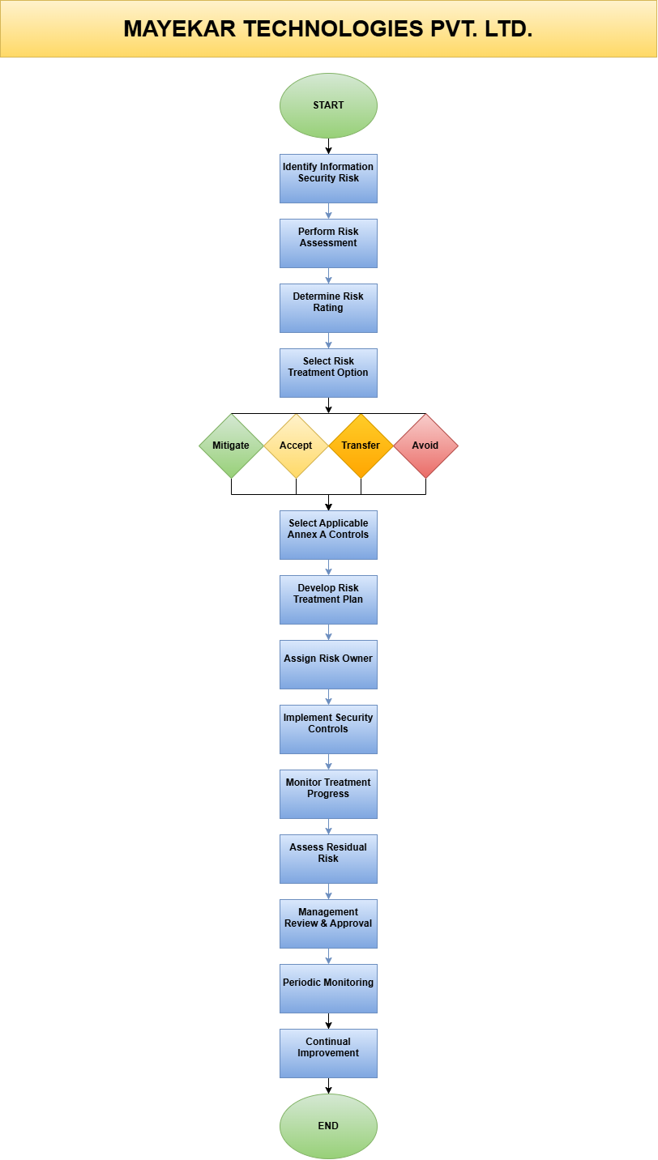
9.3 Workflow Description
Step | Description
Identify Information Security Risk | Risks are identified through assessments, audits, incidents, or business changes.
Perform Risk Assessment | Risks are analyzed to determine likelihood, impact, and overall risk level.
Determine Risk Rating | Risks are prioritized based on the organization's risk assessment methodology.
Select Risk Treatment Option | Appropriate treatment option (Mitigate, Accept, Transfer, or Avoid) is selected.
Select Applicable Annex A Controls | Relevant ISO/IEC 27001:2022 Annex A controls are identified.
Develop Risk Treatment Plan | Specific treatment activities, responsibilities, and timelines are documented.
Assign Risk Owner | Ownership is assigned to ensure accountability.
Implement Security Controls | Selected controls are implemented according to the approved plan.
Monitor Treatment Progress | Progress is tracked and implementation effectiveness is monitored.
Assess Residual Risk | Remaining risk is evaluated after control implementation.
Management Review & Approval | Management reviews treatment effectiveness and approves residual risk where appropriate.
Periodic Monitoring | Risks and controls are monitored on an ongoing basis.
Continual Improvement | Findings from audits, incidents, and reviews are used to improve the ISMS.

9.4 Workflow Principles
The Risk Treatment Workflow shall ensure that:
- Every identified risk follows a documented treatment process.
- Treatment actions are assigned to responsible risk owners.
- Applicable Annex A controls are selected based on risk assessment results.
- Treatment implementation is monitored and documented.
- Residual risks are formally assessed before closure.
- Management approves risk acceptance where applicable.
- The workflow supports continual improvement of the ISMS.

10. Risk Treatment Plan Register
10.1 Overview
The Information Security Risk Treatment Plan Register is a controlled document that records all approved treatment activities for identified information security risks. It provides a structured mechanism for assigning responsibilities, defining implementation actions, establishing target completion dates, monitoring progress, and verifying the effectiveness of implemented security controls. The register ensures that all treatment activities are tracked until completion and that residual risks remain within the organization's approved risk acceptance criteria.

10.2 Risk Treatment Plan Register Structure
The Risk Treatment Plan Register shall contain the following information:
Field | Description
Risk ID | Unique identifier assigned to each risk.
Risk Description | Brief description of the identified information security risk.
Risk Level | Risk rating determined during the risk assessment process.
Treatment Option | Selected treatment approach (Mitigate, Accept, Transfer, or Avoid).
Treatment Action | Specific action(s) planned to reduce or manage the risk.
Applicable Annex A Control | Relevant ISO/IEC 27001:2022 Annex A control(s).
Risk Owner | Individual responsible for implementing the treatment action.
Target Completion Date | Planned completion date for the treatment activity.
Implementation Status | Current implementation status (Open, In Progress, Completed).
Residual Risk | Remaining risk after implementation of treatment measures.
Review Date | Scheduled date for reviewing treatment effectiveness.

10.3 Risk Treatment Register
The complete Information Security Risk Treatment Plan Register is maintained as a controlled Microsoft Excel document. The register contains detailed treatment actions, assigned responsibilities, implementation timelines, applicable Annex A controls, monitoring status, and residual risk evaluations for all identified information security risks.
Document Reference:
Information Security Risk Treatment Plan Register.xlsx
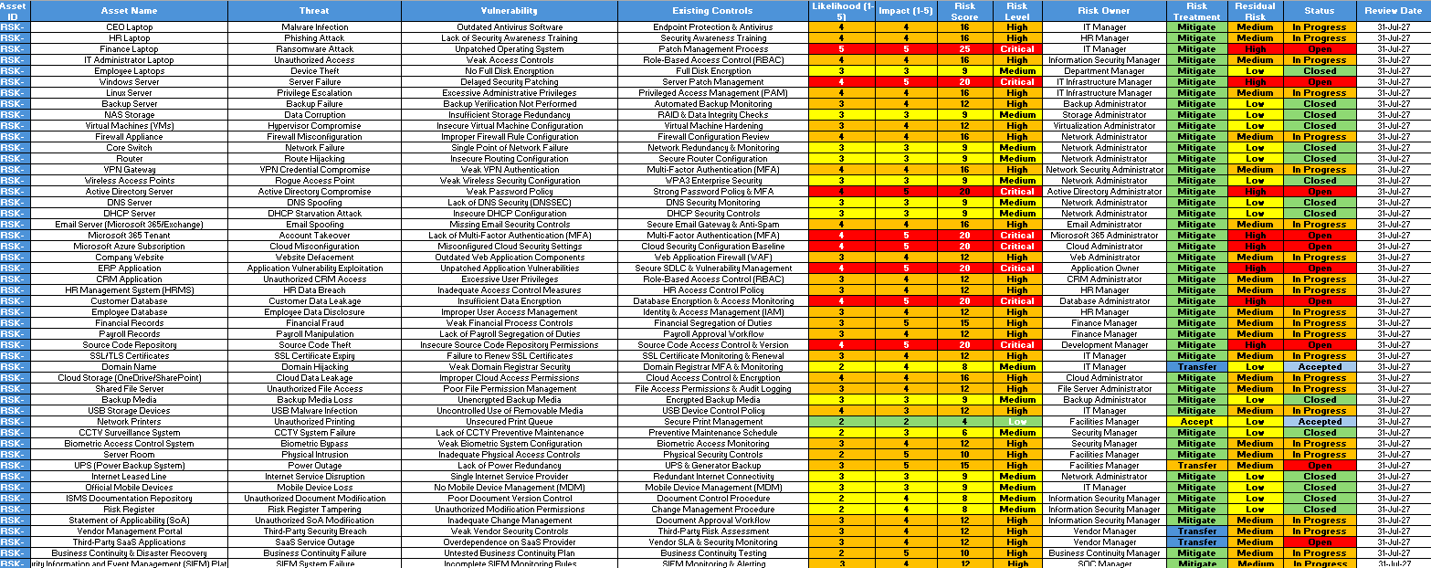

10.4 Register Maintenance
The Information Security Risk Treatment Plan Register shall be:
- Updated whenever new risks require treatment.
- Reviewed after completion of treatment activities.
- Maintained under document version control.
- Protected against unauthorized modification.
- Reviewed during Internal Audits and Management Reviews.
- Retained in the organization’s-controlled ISMS Document Repository.

10.5 Implementation Statement
The Information Security Risk Treatment Plan Register shall be maintained as the organization's official record of risk treatment activities. It shall be periodically reviewed to verify implementation progress, confirm the effectiveness of selected security controls, and ensure that residual risks remain within the organization's approved risk acceptance criteria.

11. Monitoring & Reporting
11.1 Overview
Monitoring and Reporting are essential components of the Information Security Risk Treatment Plan to ensure that approved risk treatment activities are implemented effectively, completed within the defined timelines, and continue to reduce identified information security risks to acceptable levels. Continuous monitoring enables the organization to evaluate the effectiveness of implemented security controls, identify delays or deficiencies, and take corrective actions where necessary.
Regular reporting provides management with timely information regarding the status of risk treatment activities, residual risks, implementation progress, and overall effectiveness of the Information Security Management System (ISMS), thereby supporting informed decision-making and continual improvement.

11.2 Monitoring Activities
The organization shall monitor the following activities as part of the Risk Treatment Plan:
- Progress of approved risk treatment actions.
- Implementation status of applicable ISO/IEC 27001:2022 Annex A controls.
- Effectiveness of implemented security controls.
- Residual risk levels after treatment implementation.
- Compliance with target completion dates.
- Status of High and Critical information security risks.
- Findings from internal audits and security assessments.
- Information security incidents that may affect treated risks.

11.3 Reporting Requirements
Report | Frequency | Prepared By | Reported To
Risk Treatment Status Report | Monthly | Information Security Manager | Executive Management
High & Critical Risk Report | Monthly | Information Security Manager | CEO
Risk Register Review Report | Quarterly | ISMS Team | Management Review Committee
Internal Audit Report | Annually | Internal Auditor | Executive Management
ISMS Management Review Report | Annually | Information Security Manager | Top Management

11.4 Key Performance Indicators (KPIs)
The effectiveness of the Risk Treatment Plan shall be measured using the following indicators:
- Percentage of risk treatment actions completed on time.
- Number of High and Critical risks remaining open.
- Percentage reduction in residual risk.
- Percentage of applicable Annex A controls successfully implemented.
- Number of overdue treatment actions.
- Number of repeat findings identified during internal audits.
- Number of information security incidents related to untreated risks.

11.5 Implementation Statement
The organization shall continuously monitor and report the status of information security risk treatment activities to ensure timely implementation, effective control operation, and continual improvement of the Information Security Management System (ISMS). Monitoring results shall be reviewed by management and used to support corrective actions, risk reassessment, resource allocation, and strategic information security decision-making.

12. Review & Approval
12.1 Overview
The Information Security Risk Treatment Plan shall be subject to periodic review and formal approval to ensure its continued suitability, adequacy, and effectiveness in addressing identified information security risks. The review process verifies that planned treatment activities remain aligned with the organization's business objectives, risk appetite, legal and regulatory obligations, and the requirements of ISO/IEC 27001:2022. Management approval demonstrates organizational commitment towards maintaining an effective Information Security Management System (ISMS) and ensuring continual improvement of risk treatment activities.

12.2 Review Requirements
The Information Security Risk Treatment Plan shall be reviewed under the following circumstances:
- At least once annually as part of the ISMS review cycle.
- Following significant changes to business operations, organizational structure, or technology.
- After identifying new information security risks or emerging cyber threats.
- Following major information security incidents or security breaches.
- When legal, regulatory, or contractual requirements change.
- After the completion of Internal Audits or External Certification Audits.
- Whenever significant changes are made to the Information Security Risk Register or Statement of Applicability (SoA).

12.3 Approval Authority
Role | Responsibility
Information Security Manager | Reviews the Risk Treatment Plan for completeness, accuracy, and effectiveness.
Department Heads | Validate treatment actions related to their business functions and resources.
Internal Auditor | Verifies compliance with ISO/IEC 27001:2022 requirements and organizational procedures.
Chief Executive Officer (CEO) | Provides final approval for the Risk Treatment Plan and authorizes its implementation.

12.4 Review Frequency
Activity | Frequency
Risk Treatment Plan Review | Annually
Progress Review of High & Critical Risks | Monthly
Risk Treatment Status Review | Monthly
Internal Audit Verification | Annually
Management Review | Annually

12.5 Approval Statement
The Information Security Risk Treatment Plan shall become effective only after formal review and approval by the designated management authority. Any revisions, amendments, or updates to this document shall follow the organization's Document Control Procedure and shall be subject to version control, review, approval, and communication to all relevant stakeholders before implementation.

13. Conclusion
The Information Security Risk Treatment Plan establishes a structured, risk-based approach for managing identified information security risks through the selection, implementation, monitoring, and continual improvement of appropriate security controls. By defining clear treatment strategies, assigning responsibilities, establishing implementation timelines, and monitoring treatment effectiveness, the organization ensures that information security risks are managed in a consistent and controlled manner in accordance with ISO/IEC 27001:2022 requirements.
The implementation of this Risk Treatment Plan enables Mayekar Technologies Private Limited to reduce information security risks to acceptable levels, strengthen the protection of information assets, support business continuity, enhance regulatory and contractual compliance, and improve overall organizational resilience against evolving cyber threats.
Through periodic monitoring, management review, internal audits, and continual improvement activities, the organization remains committed to maintaining an effective Information Security Management System (ISMS) that supports strategic business objectives while safeguarding the confidentiality, integrity, and availability of organizational information assets.

